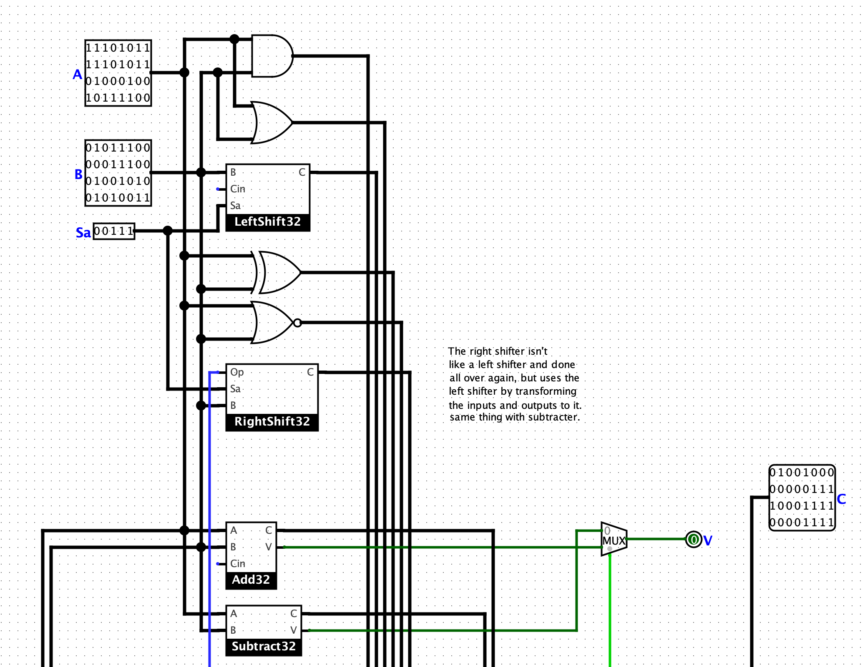

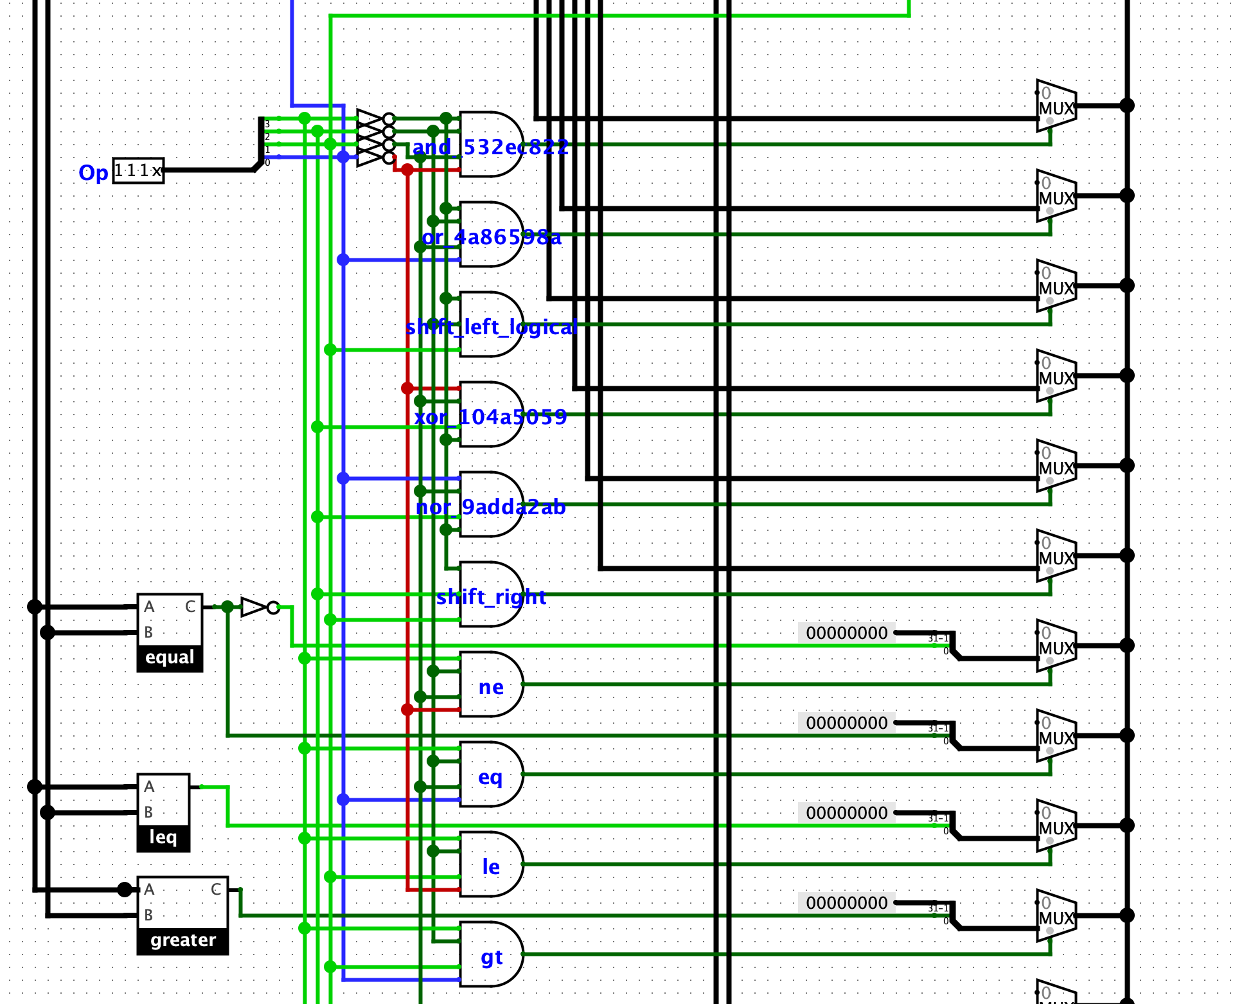

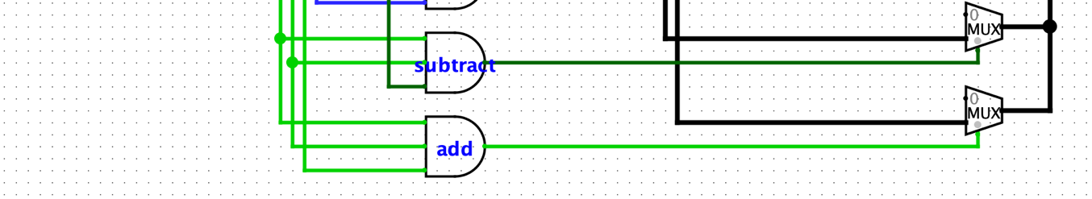

I implemented the Op codes using multi-input (3- or 4- input) and gates and transferred the corresponding operation result to the output through a multiplexer.

I did not make a right shifter like how I made a left shifter, but followed the hint about transforming inputs and outputs to the right shifter.

Similarly with the subtractor; I just transformed B to be its two’s complement and implemented overflow following rules about signed binary number addition/subtraction overflow.